The Water Cycle

MATERIALS:
Original impressionistic (hand-drawn) charts: purchase here

PRESENTATION: The Water Cycle
- Show chart 25.
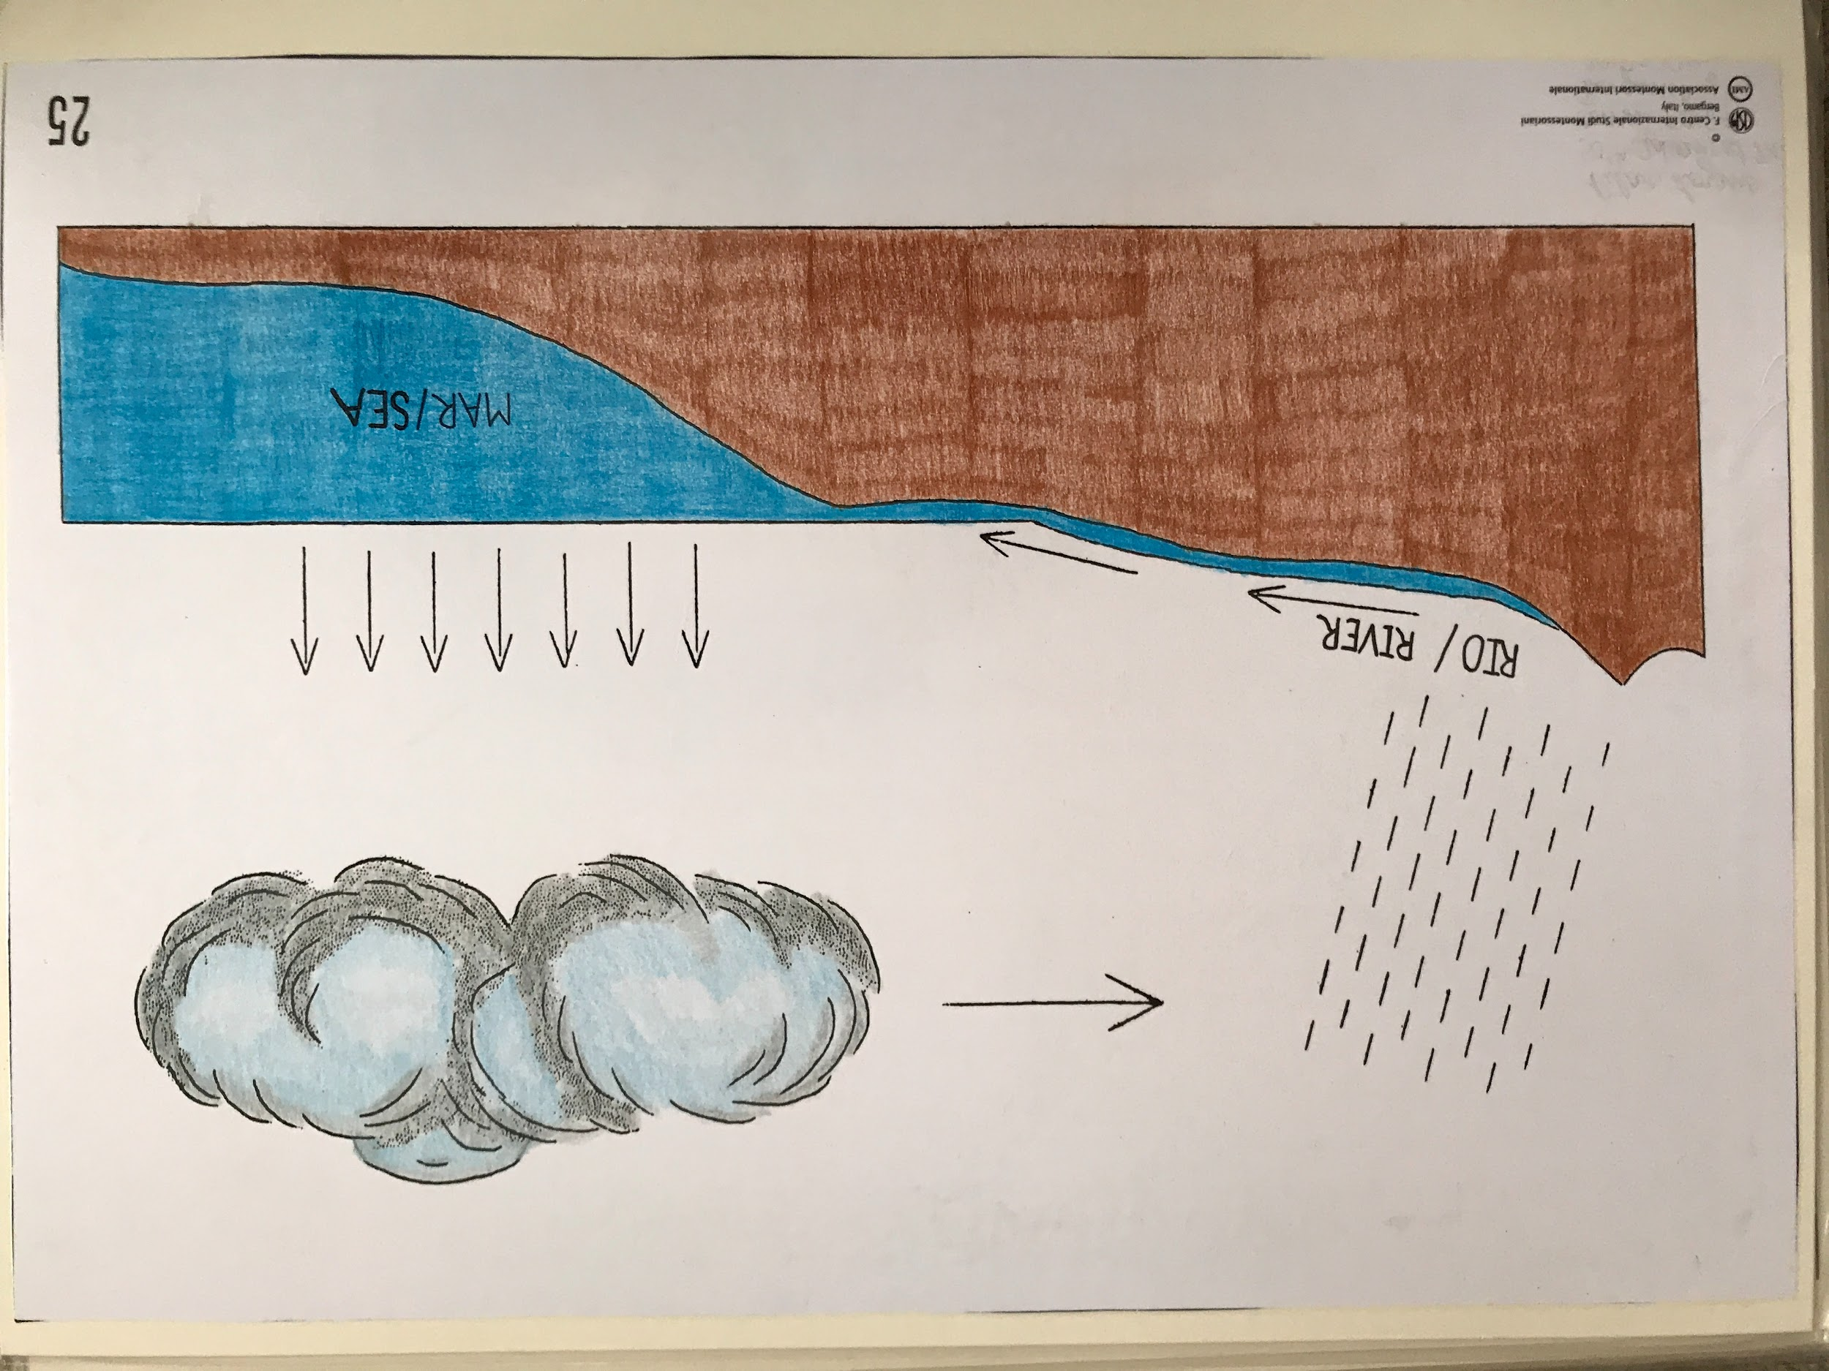
- This chart shows the water cycle. Most of the water of the planet is in the sea. We sea a clear separation between the water and the land. The ocean water is salty/sea water.
- A game is played out between the land and water, and the air and sun. Water evaporates (turns from a liquid into a gaseous state) and clouds form (tiny droplets and gas).
- Water is now being carried by the air. The wind carries the water over the land and it cools. It condenses and falls as rain over the land. It forms streams and rivers that flow back into the sea.
- Show chart 26.
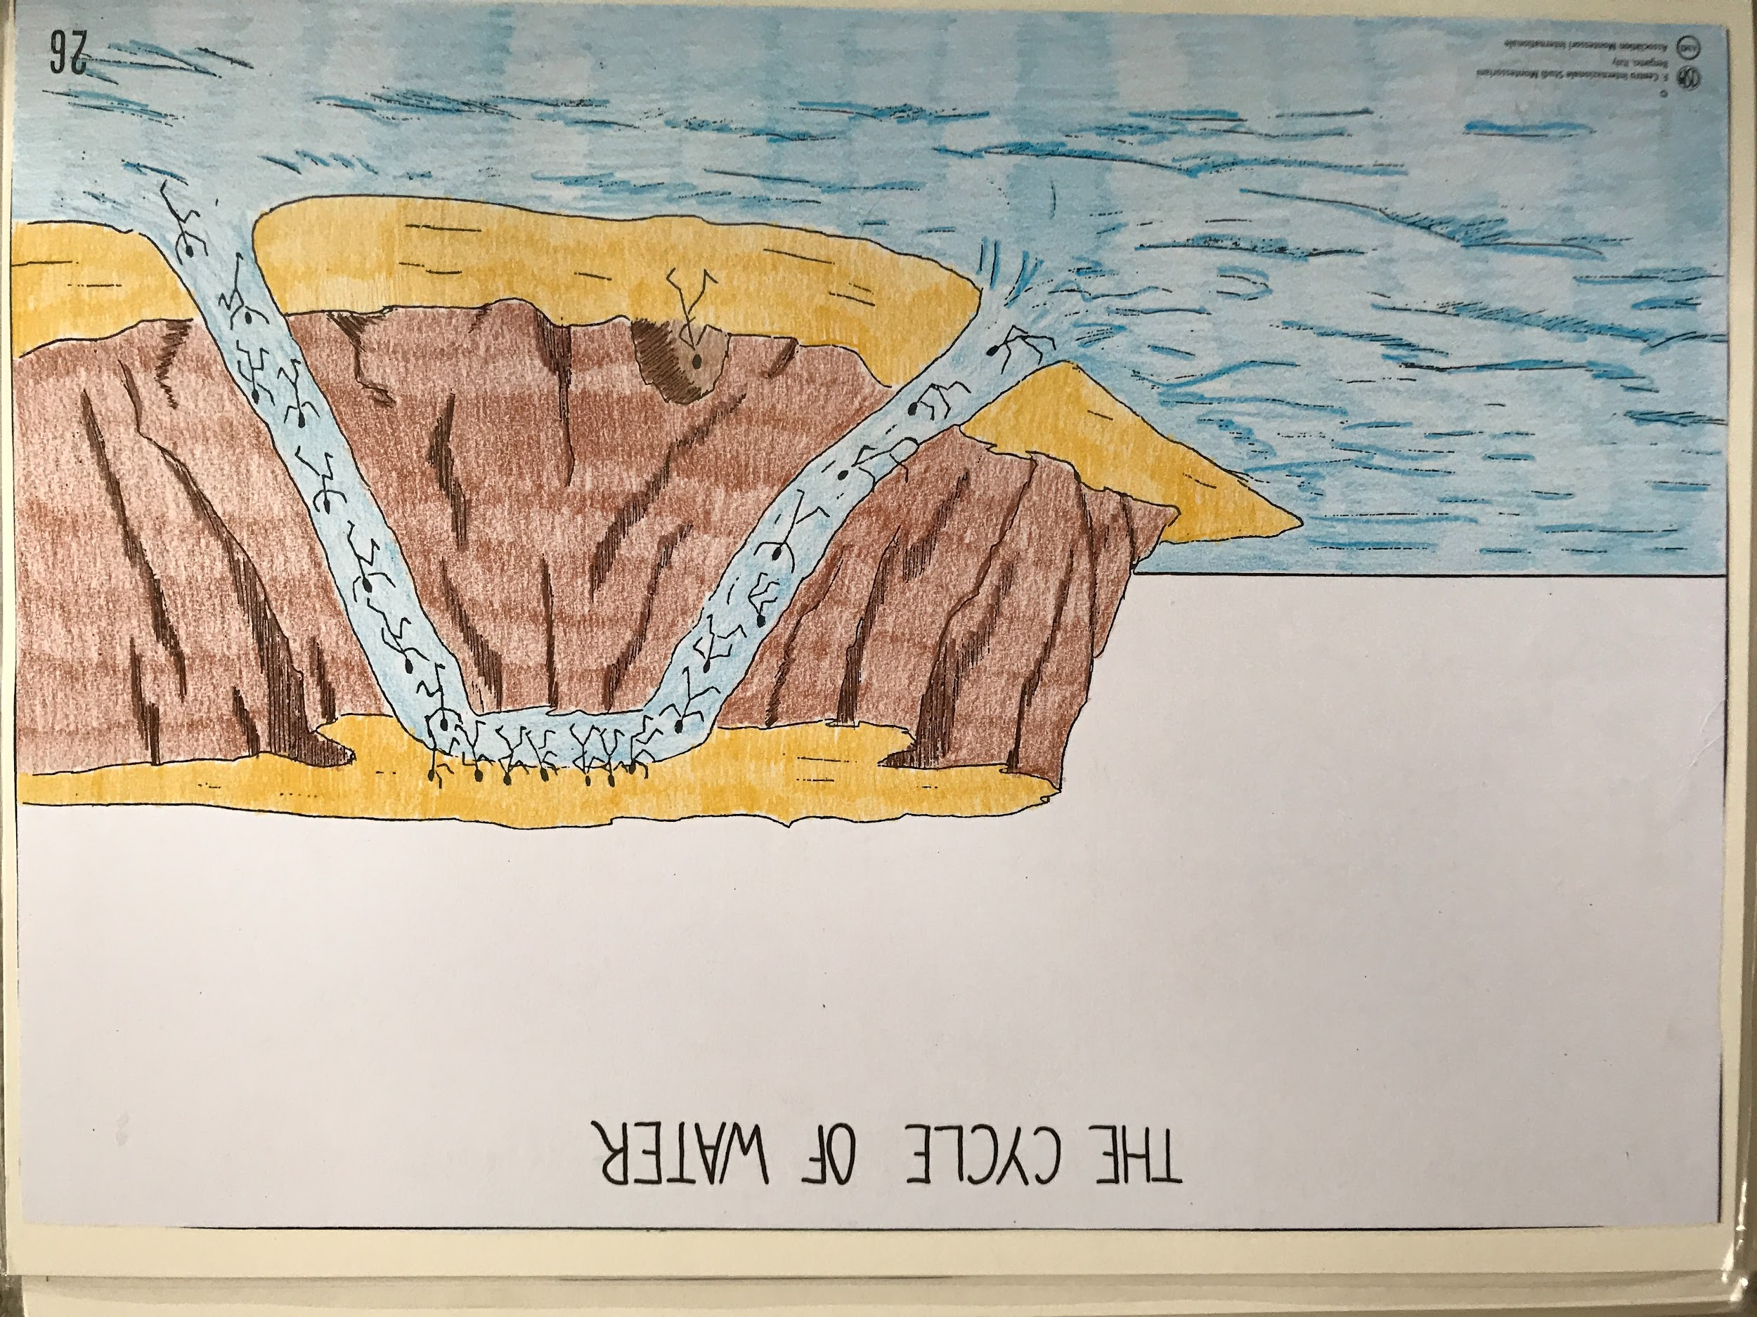
- The water is represented by children. We can think of this as a game played by children in a playground. The children climb up and then go down a slide. The little child that goes to hide in a cave represents underground water.

Water Cycle experiment

Hub VIP: Watch the Water Cycle Experiment video here
(Access the videos and get 15% off a new Hub VIP membership with code GETVIDEOS - click here!)

MATERIALS:
Baking sheet (with sides)
Ice cubes (about 8-12)
Pot with water
Single burner (or you can do this over a stove but please ALWAYS supervise!!)
Two chairs or stools, or two tall stacks of cans

PRESENTATION: Water Cycle experiment
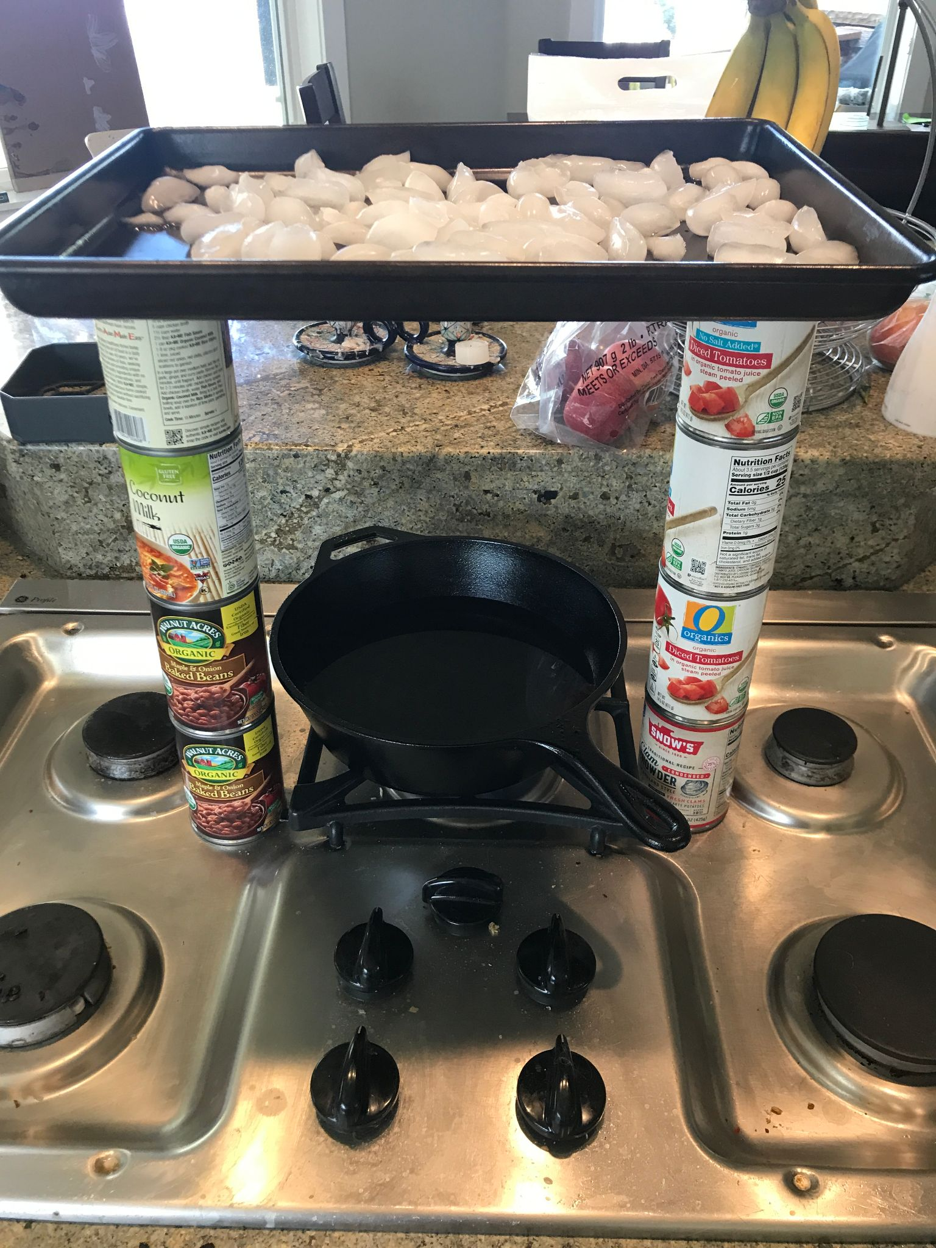
- Single burner/hot plate: Put the chairs facing each other, with the edges of the seats slightly closer together than the length of the baking sheet. The burner goes underneath the baking sheet on the floor.
- Stove: Make two stacks of three cans on either side of a burner.
- Place the baking sheet on top of the seats or cans, so that the edges are supported and the center of the sheet is suspended in mid-air.
- Fill the pot with water and place it on the burner.
- Turn the burner on and let the water boil.
- As the water heats up, place the ice cubes in the baking sheet.
- When the water starts to boil, it will evaporate and rise. The cold baking sheet will make the water condense and precipitate back down.
- Note: When the water starts to condense, you’ll see white swirls forming under the baking sheet. You can ask the children what that reminds them of (clouds).
- Tip: If the water does not rain down on its own, you can gently run a finger along the underside of the baking sheet to collect moisture, and talk about how water vapor droplets join together with particles in the clouds to create rain.

Follow-up Explorations:
- The children can do an entire exploration on underground water.
- Depending on what the children have done, we can connect this to history (The story of Life) or biology (“The Giant Drink of the Sun” chart), or the chart of the roots that take up water. Then they will see the connections.

